**AIM:** Design NFA to accept any number of a’s where input={a,b}.

**INPUT:**

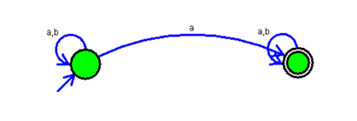

**OUTPUT:**

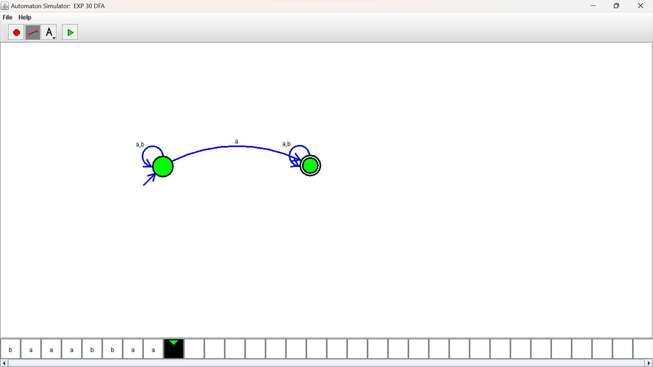

**RESULTS**:

NFA to accept any number of a’s where input={a,b}.by autosim stimulator